23rd April 2024
To all members of the Parish Council,
Notice Pursuant to Paragraph 10 (2) (b) Schedule 12 Local Government Act 1972.

Dear Councillor,
In accordance with the above provisions and notice you are hereby summoned to attend the Parish Council Meeting of Tollerton Parish Council to be held at The Scout Hut, Tollerton Lane on Wednesday 1st May 2023 at 7.15pm
The agenda for the meeting is set out as follows.
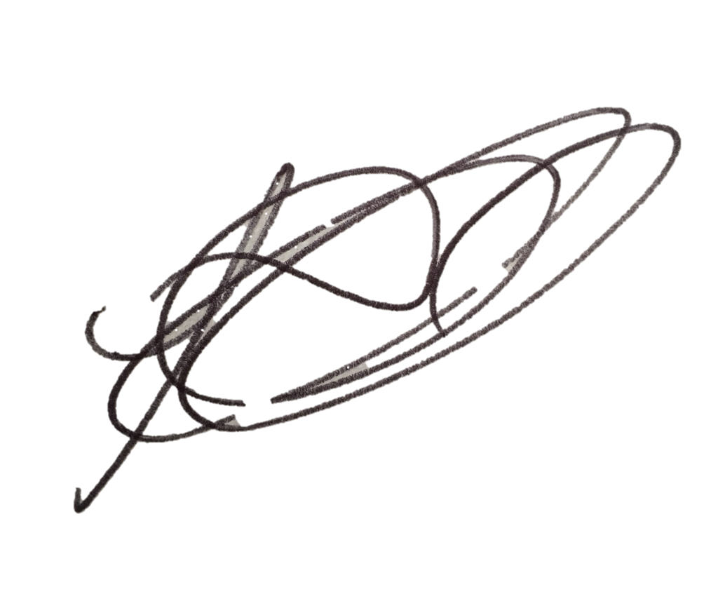
Lesa Gilbert - Executive Officer to the Council
AGENDA
- Election of Chairman for 2024/25.
- Election of Vice-Chair for 2024/25.
- To receive the declaration of acceptance to office from the newly elected Chair/Vice-Chair.
- Apologies for absence.
- Declarations of interest.
- Chairman’s announcements.
- Minutes of the Extraordinary Council meeting held on 24th April 2023 for approval.
- Review of delegation arrangements to employees and other bodies.
- Agree any committees and working groups.
- Review of representation on or work with external bodies and arrangements for reporting back.
- Review and adoption of the standing orders and financial regulations.
- Review of any other arrangements, including any charters with other local authorities, review of contributions made to expenditure incurred by other local authorities.
- Review of assets register, maintenance contracts and risks.
- Review and confirmation of arrangements for insurance cover in respect of all insured risks.
- Review of the Council’s and/or employees’ memberships of other bodies.
- Establishing or reviewing the Council’s Policies and Procedures.
- Issues, consultation and matters notified to the Parish Council.

  - Open Session for Members of the Public to Raise Matters of Council Business (Limited to 15 Minutes).

  - Consultation and public notices issued by other bodies/councils: to agree involvement and response.
    - Planning Applications:
To consider and comment on applications notified to the Parish Council – None.
Any other application received prior to the meeting.
Confirm planning applications responded to under delegated authority: - None.
Notice received of planning decisions taken by Rushcliffe Borough Council.

  - Reports – to consider reports from parish councillors, working groups and representatives on outside bodies:
    - Councillors.
    - Council representatives to the Tollerton Community Trust - Tollerton Flying Club Limited.

  - Grant applications.

- Decisions to further the objectives of Tollerton Community Plan:
To protect and enhance Rural characteristics, Community facilities and Village life, including:
    - Neighbourhood Plan – to consider progress.

- Tollerton Parish Council Services and Operations:
- Finance matters – to consider and agree matters regarding:
  - Monthly Income/Expenditure report – to note (invoices for signing).
  - Monthly Bank Reconciliation – to verify.
  - 2024-25 Budget to actuals – to note.
  - Spending under urgency delegated powers – to record for transparency: None.
  - Internal Auditor’s Report – to review report.

Annual Governance and Accountability Return (AGAR)
  - The Annual Governance Statement – to consider, approve the assertions and signed by Chair/Clerk.
  - The Accounting Statements – to review, approve and signed by Chair/RFO.
  - Exercise of Public Rights - to note the exercise of Public Rights and Publication of the unaudited Annual Governance and Accountability return will commence on Monday 3rd June 2024 and conclude on Friday 12th July 2024.

  - Maintenance of parish council assets and property.
    - War memorial slabs – to discuss improvements.
    - Painting of Parish Rooms panelling and garages – to agree.

  - Contracts and services – to consider and agree matters regarding the Council’s contracts for services.
    - Grass cutting contract 2024-25 – to agree contractor.

  - PC casual vacancy – to consider applications received.

- Parish Council Forward Plan, Action Log and the Month Ahead
- Action log – to review and agree actions for the month ahead.
- Forward Plan - to review and agree reports and decisions for forthcoming meetings.
- Date of the next PC Meeting - Wednesday 5th June 2024 at 7.30pm, The Scout Hut.

Notes for the Public: Unless otherwise stated all meetings of the Parish Council are open for the public to join. In the interests of transparency, the council asks that any person who wishes to record the meeting proceedings inform the Chairman prior to the meeting. The agenda is structured into four sections – notification of new issues, decisions on priorities and improvements, ongoing management of the council and planning ahead. There is an Open Session on the Agenda at which time members of the public are invited to raise any matters pertaining to the work of the council/agenda items, limited to fifteen minutes, during which the Standing Orders will be suspended.

