Tuesday 27th February 2024
To all members of the Parish Council,
Notice Pursuant to Paragraph 10 (2) (b) Schedule 12 Local Government Act 1972.

Dear Councillor,
In accordance with the above provisions and notice you are hereby summoned to attend the Parish Council Meeting of Tollerton Parish Council to be held at The Scout Hut, Tollerton Lane on Wednesday 6th March 2024 at 7.30pm
The agenda for the meeting is set out as follows.
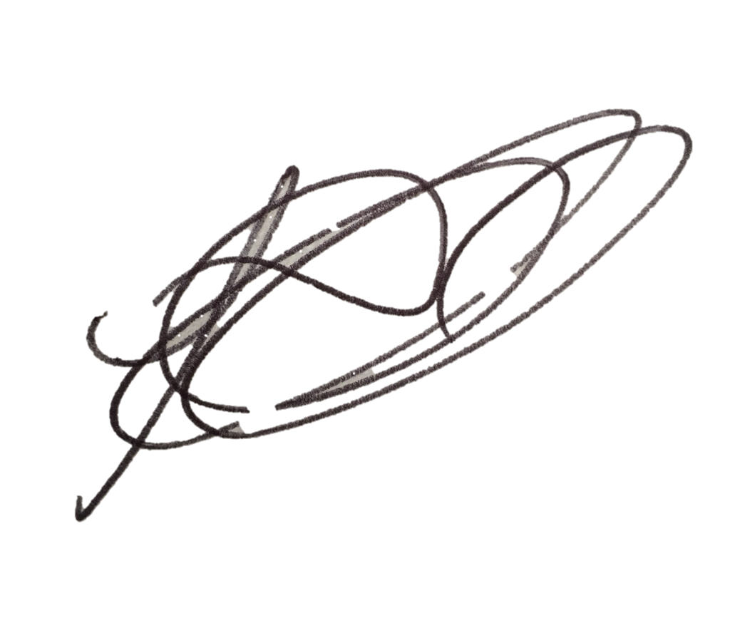
Lesa Gilbert - Executive Officer to the Council
AGENDA
- Apologies for absence.
- Declarations of interest.
- Chairman’s announcements.
- Minutes of the council meeting held on 7th February 2024 for approval/signing.
- Consultations and matters notified to the Parish Council:

  - Open Session for Members of the Public to Raise Matters of Council Business (Limited to 15 Minutes).

  - Consultation and public notices issued by other bodies/councils - to consider and agree response:
- Planning Applications:
To consider and comment on applications notified to the Parish Council:
    - 24/00169/FUL - 46 Burnside Grove – Resubmission: demolition of existing Chalet bungalow for new build house.
    - 23/02242/FUL - 30 Medina Drive – Revisions: single storey front/side/rear exts, Hip to gable/rear dormer loft conversion.
Any other application received prior to the meeting.
Confirm planning applications responded to under delegated authority: None.
Notice received of planning decisions taken by Rushcliffe Borough Council – None.

  - Reports – to consider reports from Parish Councillors and representatives on outside bodies:
    - Parish Councillors.
    - Council representatives to the Tollerton Community Trust - Tollerton Flying Club Limited.

  - Grant applications – None.

- Decisions to further the objectives of Tollerton Community Plan:
To consider matters that protect and enhance Rural characteristics, Community facilities
and Village life, including:
    - Neighbourhood Plan – to agree any further actions.

- Tollerton Parish Council Services and Operations:
- Finance matters – to consider and agree matters regarding:
  - Monthly Income/Expenditure report – to note (invoices for approval/signing).
  - Monthly Bank Reconciliation – to verify.
  - 2023-24 Budget to actuals.
  - Spending under urgency delegated powers – to record for transparency.

  - Maintenance of parish council assets and property - to consider and agree any matters.
    - Playground external inspection report – to review any actions from the report.
    - Play areas surface ground cleaning – to agree any action.

  - Contracts and services – to consider and agree matters regarding the Council’s contracts for services.
    - Office lease – to agree renewal.

- Meeting Schedule 24-25 – to confirm dates.

- Model Council Code of Conduct – to agree revisions.

- Parish Council Forward Plan, Action Log and the Month Ahead:
- Action log – to review and agree actions for the month ahead.
- Forward Plan - to review and agree reports and decisions for forthcoming meetings.
  - AGM and May Annual Parishioners Meeting 2024.
- Date of the next PC Meeting - Wednesday 3rd April 2024 at 7.30pm, The Scout Hut.

The chairman to move that the press and public be excluded from the meeting during consideration of the following agenda items on the grounds that it involves confidential information as defined in section 1 (2) of the Public Bodies (Admission to meetings) Act 1960.
- Parish Council asset matter - for consideration.

Notes for the Public: Unless otherwise stated all meetings of the Parish Council are open for the public to join. In the interests of transparency, the council asks that any person who wishes to record the meeting proceedings inform the Chairman prior to the meeting. The agenda is structured into four sections – notification of new issues, decisions on priorities and improvements, ongoing management of the council and planning ahead. There is an Open Session on the Agenda at which time members of the public are invited to raise any matters pertaining to the work of the council/agenda items, limited to fifteen minutes, during which the Standing Orders will be suspended.

