Tuesday 26th December 2023

To all members of the Parish Council,
Notice Pursuant to Paragraph 10 (2) (b) Schedule 12 Local Government Act 1972.

Dear Councillor,
In accordance with the above provisions and notice you are hereby summoned to attend the Parish Council Meeting of Tollerton Parish Council to be held at The Scout Hut, Tollerton Lane on Wednesday 3rd January 2024 at 7.30pm
The agenda for the meeting is set out as follows.
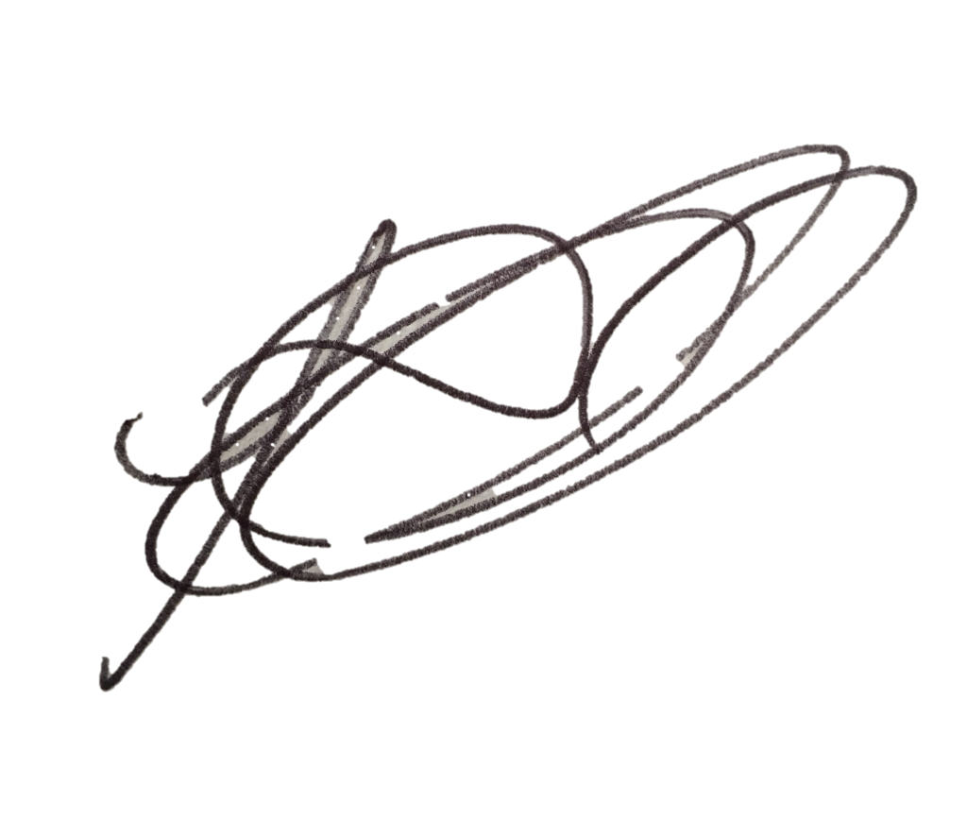
Lesa Gilbert - Executive Officer to the Council

AGENDA

- Apologies for absence.
- Declarations of interest.
- Chairman’s announcements.
- Minutes of the council meeting held on 6th December 2023 for approval/signing.
- Consultations and matters notified to the Parish Council:

  - Open Session for Members of the Public to Raise Matters of Council Business (Limited to 15 Minutes).

  - Consultation and public notices issued by other bodies/councils - to consider and agree response:
- Neighbourhood plan – review examiner questions.

- Planning Applications:
To consider and comment on applications notified to the Parish Council:
    - 23/02242/FUL - 30 Medina Drive - Single storey front/side/rear exts. Hip to gable and rear dormer loft conversion.
Any other application received prior to the meeting.
Confirm planning applications responded to under delegated authority: None.
Notice received of planning decisions taken by Rushcliffe Borough Council.

  - Reports – to consider reports from Parish Councillors and representatives on outside bodies:
    - Parish Councillors.
    - Council representatives to the Tollerton Community Trust - Tollerton Flying Club Limited.

  - Biodiversity duty for Parish Councils – agree policy and objectives.

  - Grant applications – None.

- Decisions to further the objectives of Tollerton Community Plan:
To consider matters that protect and enhance Rural characteristics, Community facilities
and Village life, including:
    - Annual review of progress, ambitions for the year ahead and budget priorities
    - Active Tollerton Project - to review progress and agree any further actions.
- Set up of composting toilet, consumables, cleaning and maintenance.
    - Your Tollerton Village Centre Project – to review progress and agree any further actions.

- Tollerton Parish Council Services and Operations:
- Finance matters – to consider and agree matters regarding:
  - Monthly Income/Expenditure report – to note (invoices for approval/signing).
  - Monthly Bank Reconciliation – to verify.
  - 2022-24 Budget to actuals.
  - Spending under urgency delegated powers – to record for transparency.
  - Medium Term Financial Strategy and Budget -
to review budget principles and approve the financial strategy,
to review budget against priorities and the draft statement of proposed expenditure and
to agree a budget and precept for 2024/25.

  - Maintenance of parish council assets and property - to consider and agree any matters.
    - PAT Testing
    - Replacement of flood light to rear of parish rooms
    - Christmas lights on methodist tree

  - Contracts and services – to consider and agree matters regarding the Council’s contracts for services.

- Parish Council Forward Plan, Action Log and the Month Ahead:
- Action log – to review and agree actions for the month ahead.
- Forward Plan - to review and agree reports and decisions for forthcoming meetings.
- Date of the next PC Meeting - Wednesday 7th February 2024 at 7.30pm, The Scout Hut.

Notes for the Public: Unless otherwise stated all meetings of the Parish Council are open for the public to join. In the interests of transparency, the council asks that any person who wishes to record the meeting proceedings inform the Chairman prior to the meeting. The agenda is structured into four sections – notification of new issues, decisions on priorities and improvements, ongoing management of the council and planning ahead. There is an Open Session on the Agenda at which time members of the public are invited to raise any matters pertaining to the work of the council/agenda items, limited to fifteen minutes, during which the Standing Orders will be suspended.

