Tuesday 6th June 2023

To all members of the Parish Council,
Notice Pursuant to Paragraph 10 (2) (b) Schedule 12 Local Government Act 1972.

Dear Councillor,
In accordance with the above provisions and notice you are hereby summoned to attend the Parish Council Meeting of Tollerton Parish Council to be held at The Scout Hut, Tollerton Lane on Wednesday 14th June 2023 at 7.30pm
The agenda for the meeting is set out as follows.
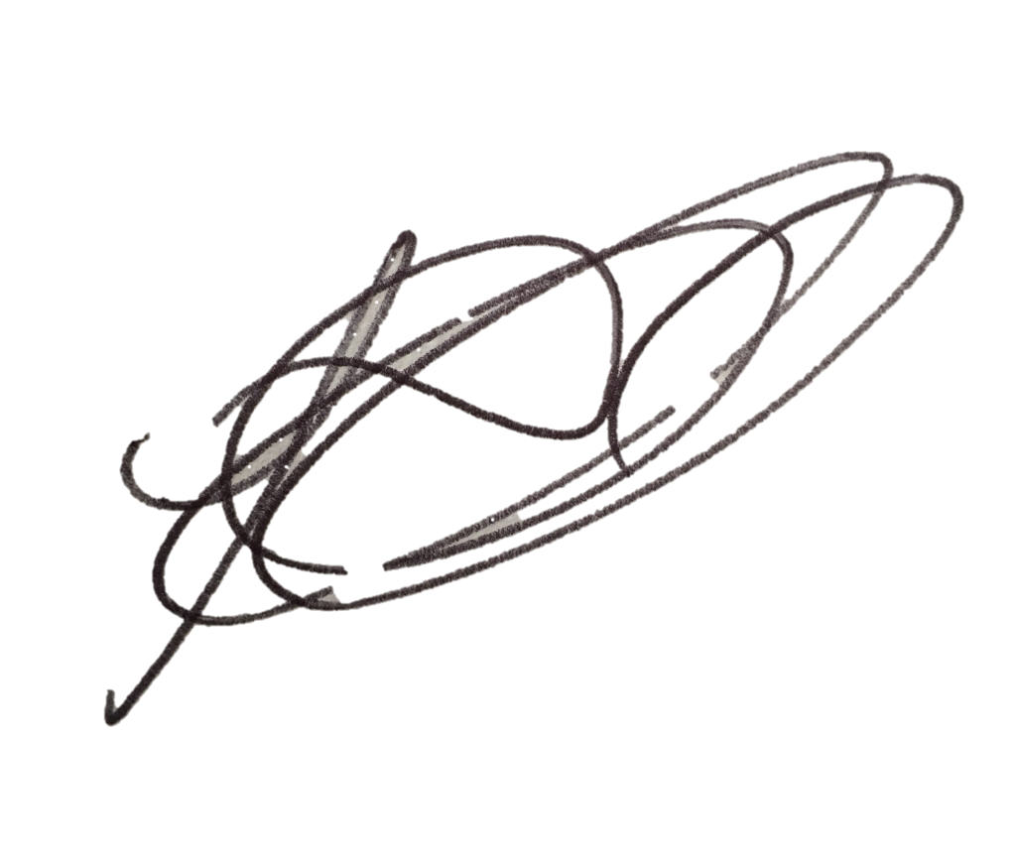
Lesa Gilbert - Executive Officer to the Council

AGENDA

- Apologies for absence.
- Declarations of interest.
- Chairman’s announcements.
- Minutes of the council meeting held on 10th May 2023 for approval/signing.
- Issues, consultation and matters notified to the Parish Council.

  - Open Session for Members of the Public to Raise Matters of Council Business (Limited to 15 Minutes).

  - Consultation and public notices issued by other bodies/councils: to agree involvement and response.
    - Planning Applications:
To consider and comment on applications notified to the Parish Council:
a. 23/00968/FUL - 82 Cotgrave Lane - Conversion of existing outbuilding to form a new house inc. single storey ext to south.
Any other application received prior to the meeting.
Confirm planning applications responded to under delegated authority: -
b. 23/00939/FUL - 7 Lothian Road - 2 storey side ext/ Single storey rear ext. - DNO.

Notice received of planning decisions taken by Rushcliffe Borough Council:
c. 23/00588/FUL - 30 Burnside Grove - replacement of existing heat pump – Granted.
d. 23/00046/FUL- B T Hoyland and Sons, Little Lanes - Change of use of existing agricultural piggerie building to light
storage with associated parking – Refused: unadopted road.
e. 23/00256/FUL - 75 Tollerton Lane - Single Storey rear and side extension. New hipped roof to side elevation. - Granted.

  - Reports – to consider reports from parish councillors, working groups and representatives on outside bodies:
    - Councillors.
    - Council representatives to the Tollerton Community Trust - Tollerton Flying Club Limited.

  - Grant applications.

- Decisions to further the objectives of Tollerton Community Plan:
  - To protect and enhance Rural characteristics, Community facilities and Village life, including:
    - Neighbourhood Plan – to consider progress.

- Tollerton Parish Council Services and Operations:
- Finance matters – to consider and agree matters regarding:
  - Monthly Income/Expenditure report – to note (invoices for approval/signing).
  - Monthly Bank Reconciliation – to verify.
  - 2022-23 Budget to actuals.
  - Spending under urgency delegated powers – to record for transparency:
a. Defibrillator battery - £113.
b. No stopping cones - £149.
c. Metal barrier stakes - £42.

  - Maintenance of parish council assets and property.
    - Your Tollerton Village Centre Project – to review progress and agree any further actions.
    - Active Tollerton Project - to review progress and agree any further actions.
    - Parish Rooms stairs to flats.

  - Contracts and services – to consider and agree matters regarding the Council’s contracts for services.
    - Grass cutting.

- Parish Council Forward Plan, Action Log and the Month Ahead
- Action log – to review and agree actions for the month ahead.
- Forward Plan - to review and agree reports and decisions for forthcoming meetings.
- Date of the next PC Meeting - Wednesday 5th July 2023 at 7.30pm, The Scout Hut.

Notes for the Public: Unless otherwise stated all meetings of the Parish Council are open for the public to join. In the interests of transparency, the council asks that any person who wishes to record the meeting proceedings inform the Chairman prior to the meeting. The agenda is structured into four sections – notification of new issues, decisions on priorities and improvements, ongoing management of the council and planning ahead. There is an Open Session on the Agenda at which time members of the public are invited to raise any matters pertaining to the work of the council/agenda items, limited to fifteen minutes, during which the Standing Orders will be suspended.

