Tuesday 21st February 2023

To all members of the Parish Council,
Notice Pursuant to Paragraph 10 (2) (b) Schedule 12 Local Government Act 1972.

Dear Councillor,
In accordance with the above provisions and notice you are hereby summoned to attend the Parish Council Meeting of Tollerton Parish Council to be held at The Parish Room’s, Burnside Grove on Wednesday 1st March 2023 at 7.30pm
The agenda for the meeting is set out as follows.
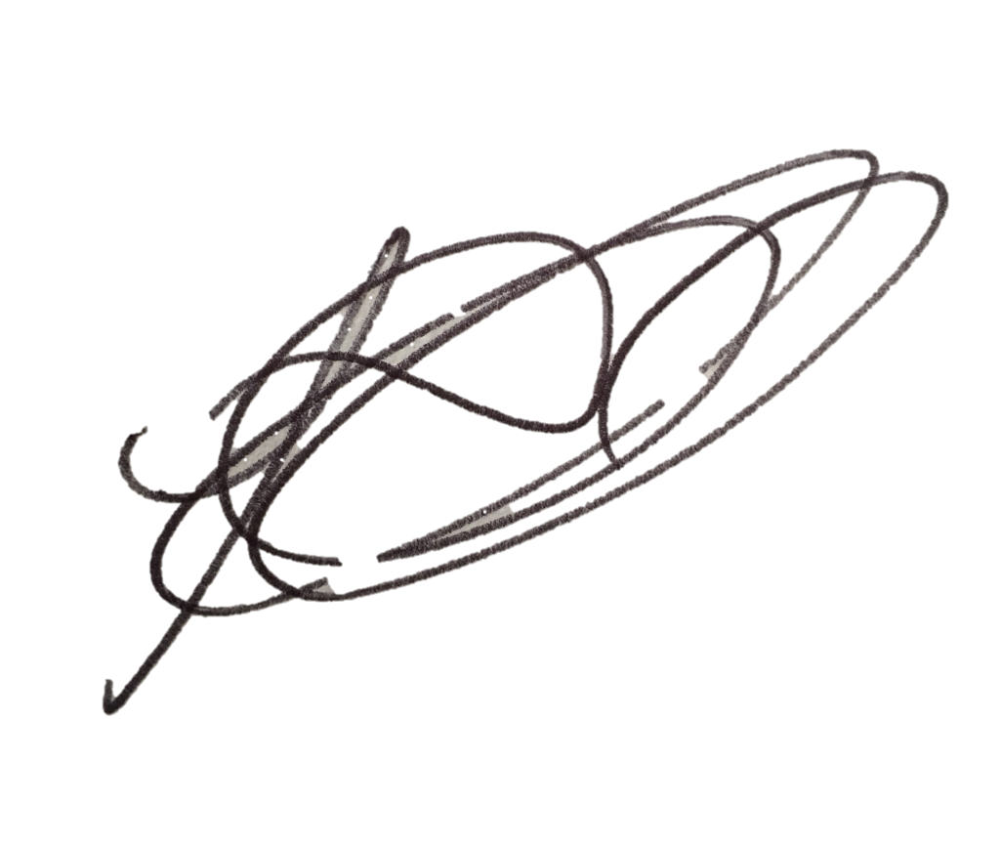
Lesa Gilbert - Executive Officer to the Council

AGENDA

- Apologies for absence.
- Declarations of interest.
- Chairman’s announcements.
- Minutes of the council meeting held on 01 February 2023 for approval/signing.
- Issues, consultation and matters notified to the Parish Council.

  - Open Session for Members of the Public to Raise Matters of Council Business (Limited to 15 Minutes).

  - Consultation and public notices issued by other bodies/councils: to agree involvement and response.
    - Planning Applications:
To consider and comment on applications notified to the Parish Council, including
    - 23/00046/FUL - B T Hoyland Farm - Change of use: agricultural piggerie building to light storage/associated parking.
    - 23/00096/SCOEIA | Scoping request – North of Tollerton / East of Gamston
    - Any other application received prior to the meeting.
Confirm planning applications responded to under delegated authority: - None.
Notice received of planning decisions taken by Rushcliffe Borough Council:
    - No decision notices to report.

  - Reports – to consider reports from parish councillors, working groups and representatives on outside bodies:
    - Councillors.
    - Council representatives to the Tollerton Community Trust - Tollerton Flying Club Limited.

  - Grant applications.
    - None.

- Decisions to further the objectives of Tollerton Community Plan:
  - To protect and enhance Rural characteristics, Community facilities and Village life, including:
    - Neighbourhood Plan – to consider progress.
    - Meeting Schedule 2023-24, Annual Parishioners Meeting and May Elections – to agree plans.

- Tollerton Parish Council Services and Operations:
- Finance & expenditure – to consider and agree matters regarding the monthly statement of budget and expenditure, including:
  - Invoices for approval – to review and agree payments.
  - Spending under urgency delegated powers – to record for transparency.
    - New defibrillator battery/pads (Tollerton Lane Defib) £113.95 -VAT.

  - Maintenance of parish council assets and property.
    - Your Tollerton Village Centre Project – to review progress and agree any further actions including works to the parish rooms.
    - Active Tollerton Project - to review options for toilets and changing rooms for the Open Space.

  - Contracts and services – to consider and agree matters regarding the Council’s contracts for services.
    - Electric supply for Christmas lights – to review and agree.
    - Insurance renewal – to review and agree.
    - Playground repairs – to review quotes.

- Parish Council Forward Plan, Action Log and the Month Ahead
- Action log – to review and agree actions for the month ahead.
- Forward Plan - to review and agree reports and decisions for forthcoming meetings.
- Date of Next Parish Council Meeting - Wednesday 5th April 2023 at 7.30pm, The Scout Hut -TBC.

The chairman to move that the press and public be excluded from the meeting during consideration of the following agenda items on the grounds that it involves confidential information as defined in section 1 (2) of the Public Bodies (Admission to meetings) Act 1960.

- Employment matters update.

Notes for the Public: Unless otherwise stated all meetings of the Parish Council are open for the public to join. In the interests of transparency, the council asks that any person who wishes to record the meeting proceedings inform the Chairman prior to the meeting. The agenda is structured into four sections – notification of new issues, decisions on priorities and improvements, ongoing management of the council and planning ahead. There is an Open Session on the Agenda at which time members of the public are invited to raise any matters pertaining to the work of the council/agenda items, limited to fifteen minutes, during which the Standing Orders will be suspended.

