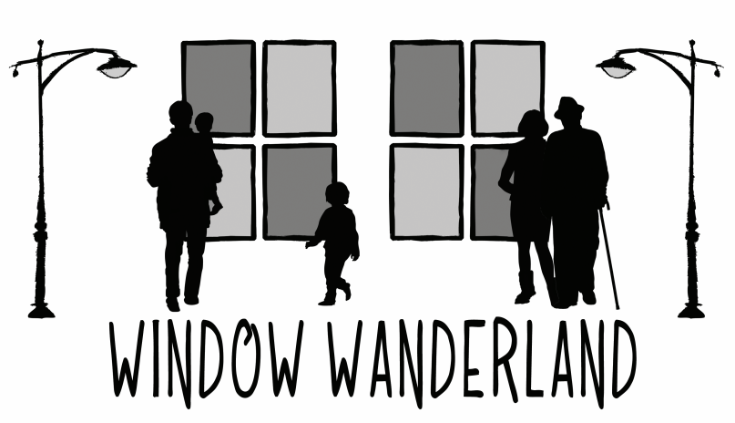
Walk around the village and see the Christmas displays and lights

This Friday
Saturday and Sunday
5.30pm – 8.30pm

Tollerton Winter Window Wanderland
Friday, Saturday and Sunday
5.30pm – 8.30pm

Over 30 Displays to Visit
Get Your Map Here

This is a free event but please consider leaving a donation for local food banks around the village Christmas Tree

Tollerton Winter Window Wanderland
Friday, Saturday and Sunday
5.30pm – 8.30pm

This is a free event but please consider leaving a donation for local food banks here around the village Christmas Tree

Tollerton Winter Window Wanderland
Friday, Saturday and Sunday
5.30pm – 8.30pm

Stalls
Local Art and Crafts - Parish Rooms
Sweets from the scouts - Methodist Church
Coffee in the Village Centre
Hot Food, Mulled Wine, Beer and Lager to takeaway from the Air Hostess

**Stalls Friday and Saturday only**
Please maintain social distancing at all times

Tollerton Winter Window Wanderland
Friday, Saturday and Sunday
5.30pm – 8.30pm

Covid-19
Please follow Government Guidance at all times in particular the rule of six and 2m and instructions from stall holders

Please note all food/drink from the Air Hostess is takeaway only and must not be consumed on the premises

Please do not gather in the village centre after making your purchases

